Appendix A
User’s Manual

ACCESSING THE MOBILE APPLICATION
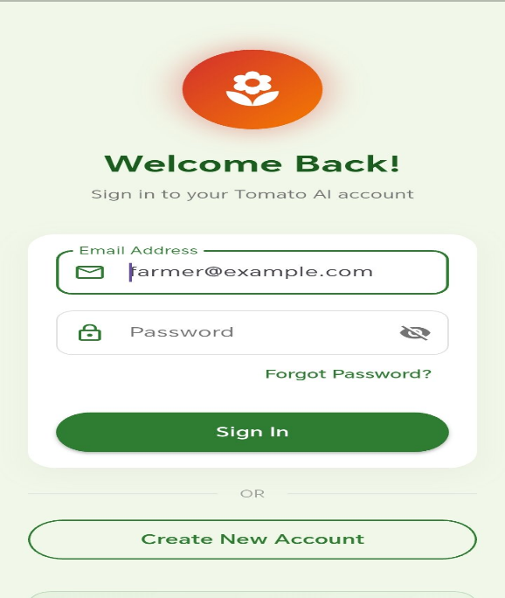
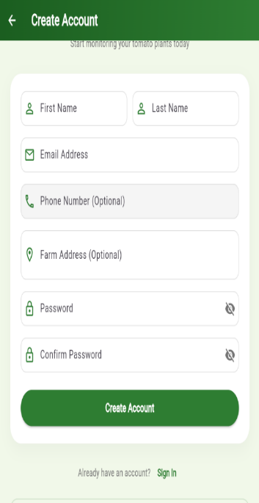
- LOGIN / SIGN UP PAGE

Upon opening the Tomato AI Assistant app, users are greeted by the Sign Up and Login screen. New users must register using a valid email address and password, while returning users can enter their credentials to access their personalized dashboard.
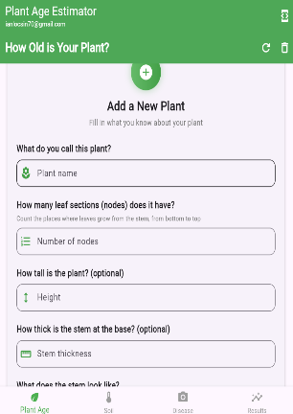
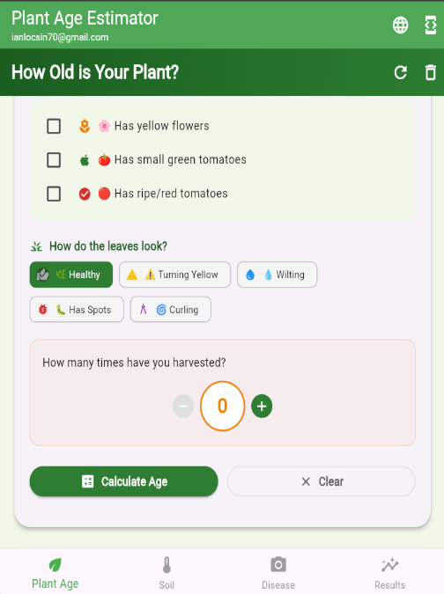
- TOMATO PLANT PROFILING PAGE

Navigate to the "Plant Details" or "New Plant" screen to register a new tomato plant in the system for personalized tracking. You will be asked to enter required information such as Plant Variety (e.g., Cherry, Roma), Planting Date, and initial health notes. The system then creates a unique profile for the plant to track its progress.
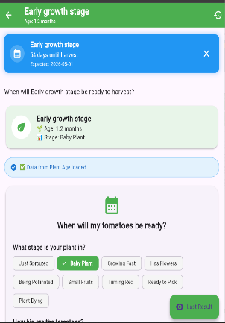
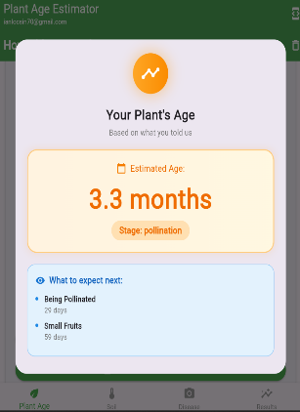
- GROWTH STAGE & HARVEST PREDICTION

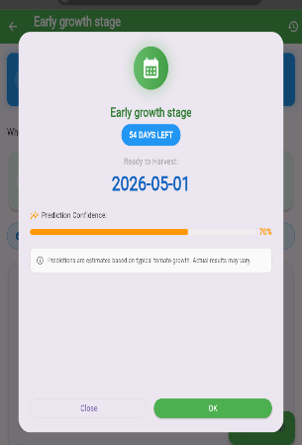
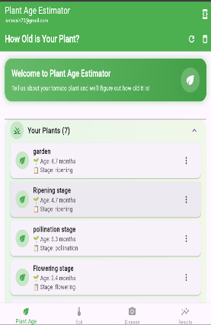

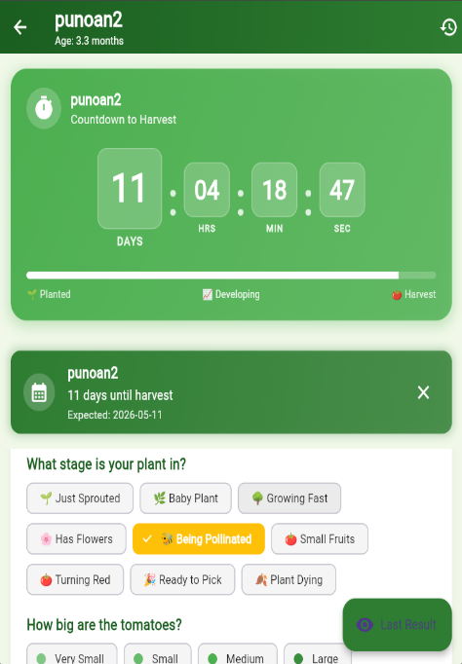
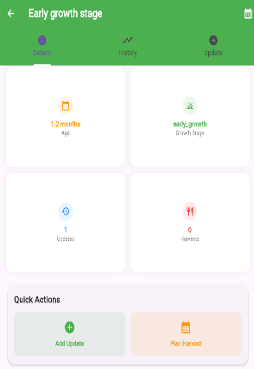

Select a plant from your list of profiles to view its current developmental stage. The system will automatically display its current Growth Stage. An Estimated Harvest Date is then calculated based on the planting date and typical growth timelines to help you plan farm activities.
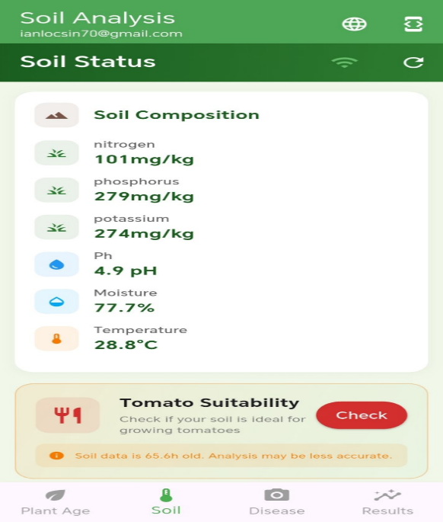
- REAL-TIME SOIL DATA

Tap on the "Soil Status" or similar button on the dashboard to view live soil conditions gathered from the ESP32-based 7-in-1 soil sensor. The screen displays readings for Moisture (%), Temperature (°C), pH Level, and Nutrient Levels (NPK) including Nitrogen (N), Phosphorus (P), and Potassium (K).
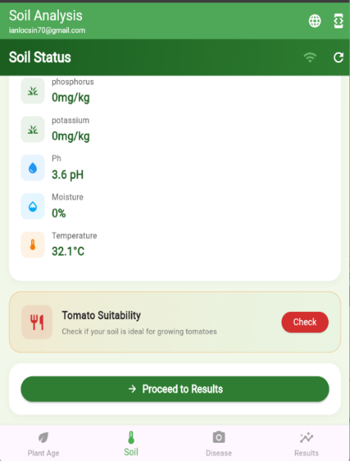
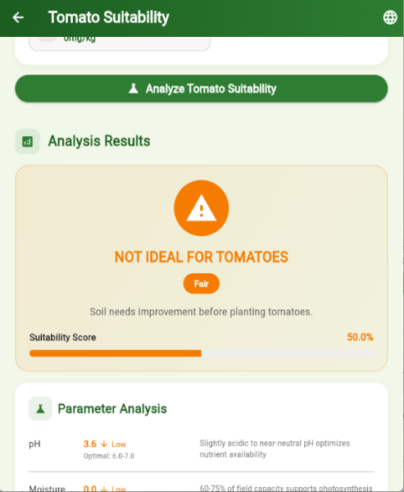
- SOIL SUITABILITY CHECK

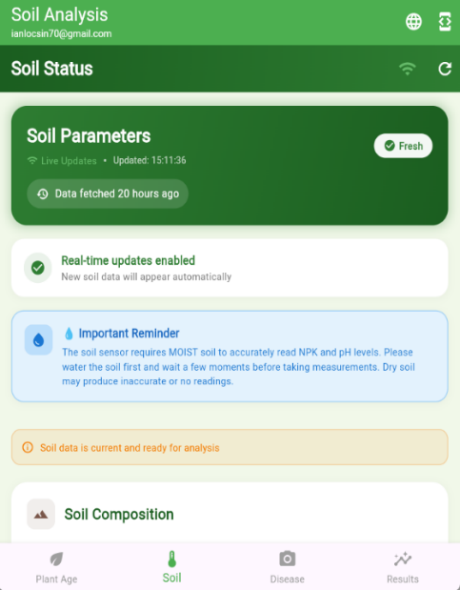

On the Soil Status page, click the "Check Soil Suitability" button to determine if the current soil conditions are optimal for tomato growth. The system compares the live sensor data against optimal ranges and returns a verdict while providing direct recommendations for amendments like watering or fertilization.

- CAPTURE & UPLOAD PLANT IMAGE
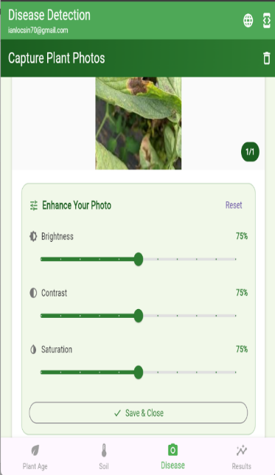
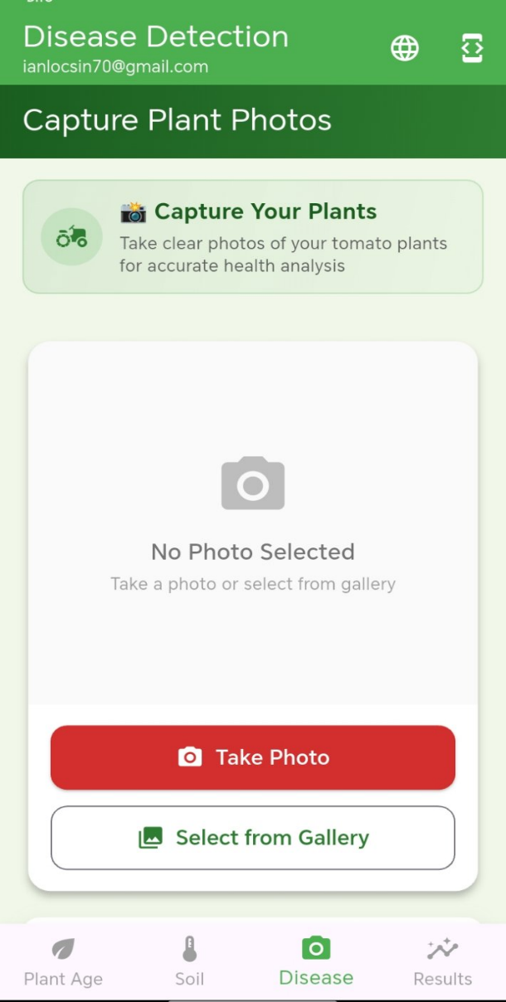

Navigate to the "Capture and Upload Image" screen to take a photo of a tomato leaf or fruit for disease detection. You may either take a new photo using your phone's camera or select an existing image from your gallery, ensuring the photo is clear and well-lit while focusing on the leaf or fruit surface. The "Image Enhancement" screen allows you to adjust brightness or contrast to improve image clarity before analysis.
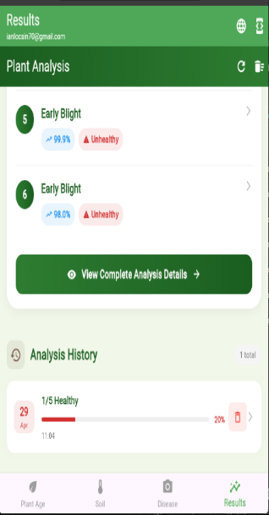
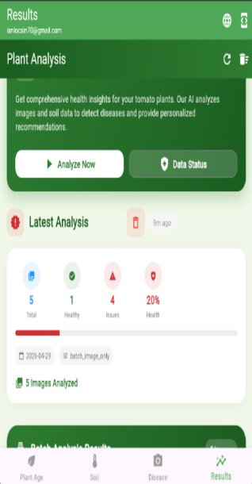
- AI ANALYSIS & RESULTS

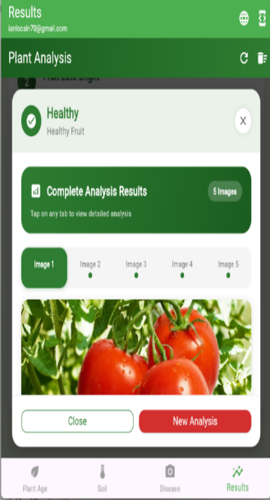

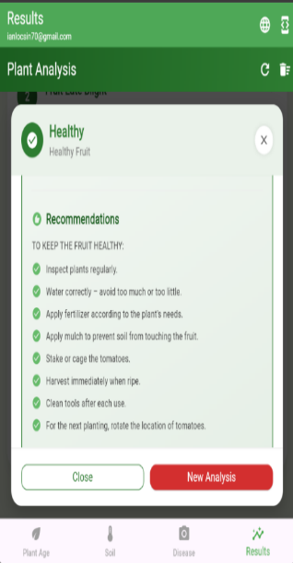

After capturing an image, tap the "Analyze Now" button to receive an automated diagnosis of the plant's health. The AI system processes the image and displays an Analysis Output screen which includes the confirmed Plant Type as "Tomato," the Health Status, a summary of the latest sensor data integrated with the analysis, and actionable Recommendations such as "Apply copper-based fungicide" or "Soil phosphorus is low; add bone meal.
- REQUIREMENTS AND BEST PRACTICES GUIDE
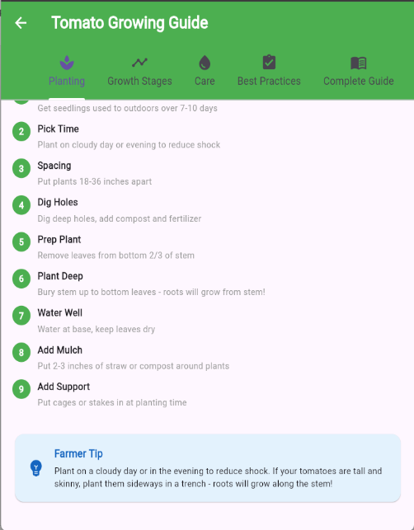
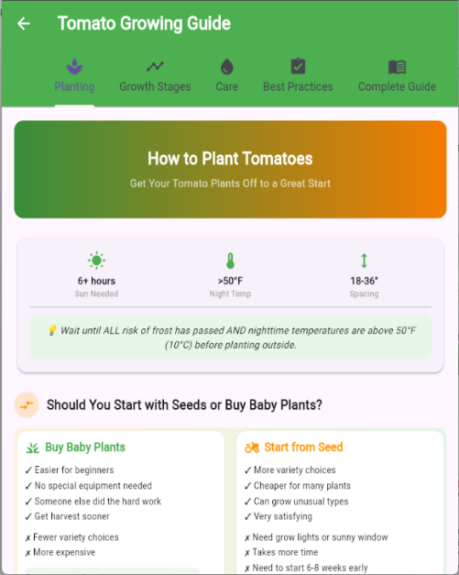

Tap the "Best Practices and Tips" icon to access a static reference for optimal tomato cultivation techniques. The app displays expert guides on topics such as proper watering, spacing, pruning, and integrated pest management for common tomato diseases.
- ANALYSIS HISTORY
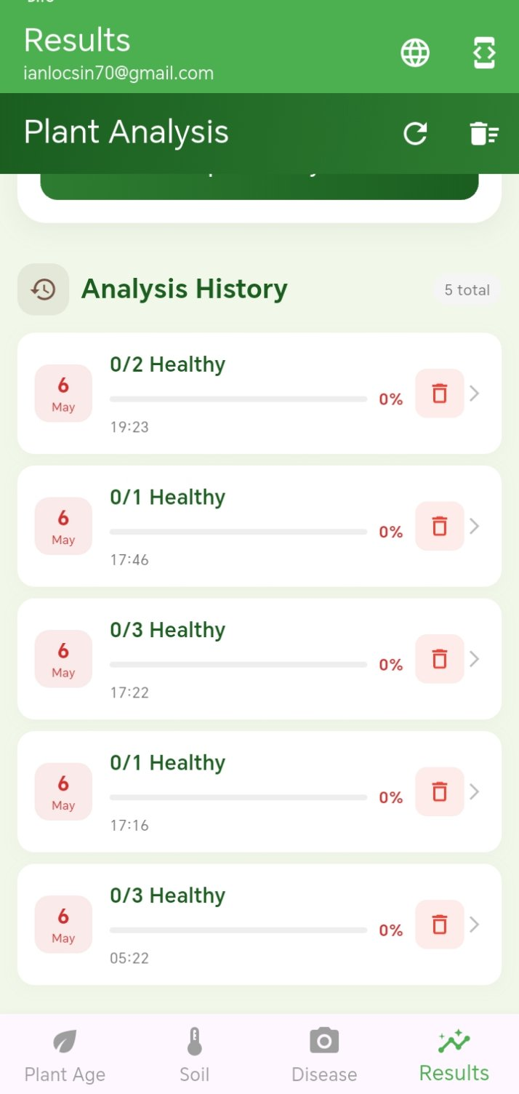

Tap the "History" icon to review past diagnoses, soil readings, and recommendations. The app shows a chronological list of all previous plant analyses, and selecting an entry allows you to view the full report again to track the progression of a plant's health over time.
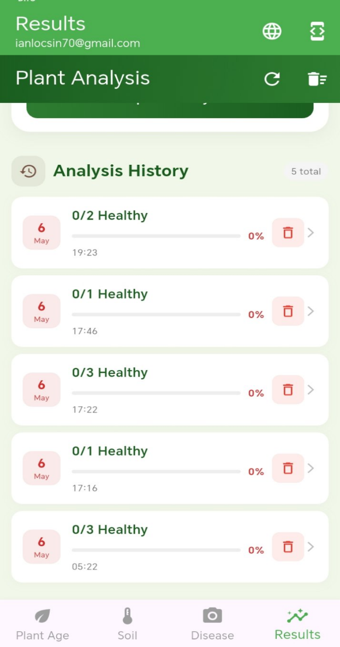
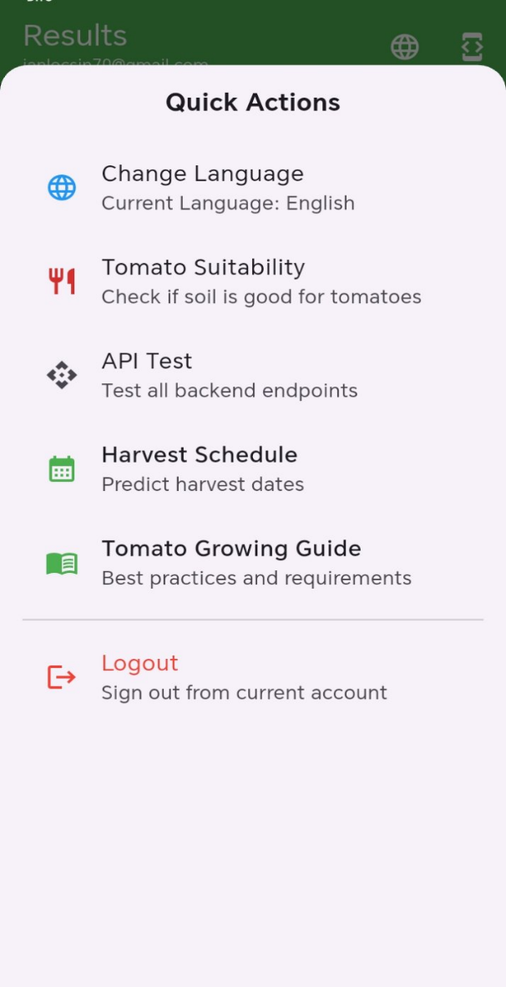
- LOGOUT

To logout the application, navigate to this icon on the top right of the screen and click it. Quick Actions will display and then find the Logout label, clicking it will then logout the user and displays the login screen.

